­­



**Kolbe Catholic College**

**Year 8 Science**

Student Name: ___________________________________

Teacher: ____________________________________

**2021 Task 2: Body Systems Scientific Investigation**

**Due Date: _________________________**

**Task Weighting**: 25% for Semester 1

**Time allotment:**

1 Period: Planning investigation (Group Work)

1 Period: Conducting investigation (Group Work)

2 Periods: Writing investigation (Individual Work)

1 Period: Validation Extended Answer (Individual Work)

Part A: Body Systems Scientific Investigation _____ / 38 Marks

Part B: Validation Extended Answer _____ / 26 Marks

Total: _____ / 64 Marks

**Your assessment goals:**

1. Plan and conduct a science investigation that is a fair test.
2. Analyse and evaluate the results.
3. Interpret the results in relation to ‘Why does exercise affect heart rate’?

**Your Task**

To conduct an investigation over one period to find out how heart rate is affected by exercise. The design of the investigation is up to you, but here are some questions to help guide you:

* How will you vary your chosen physical activity to achieve different heart rates?
* How will you measure your heart rate?

**How long will you need?**

* One period to design your investigation (create planning document)
* One period to conduct your investigation (group work)
* Two periods to write up your report (Including your graph)
* One Period to complete the validation extended answer (20 Minutes)

In class, we have been learning about the respiratory system and the circulatory system. Both of these systems must work together to ensure that your body is able to get all of the nutrients that you need but also to make sure that all of the waste products that you produce are removed.

We know that we breathe in oxygen and that we breathe out carbon dioxide. This is because all of our cells undergo the process of cellular respiration. During this process, our cells are able to get the energy out of the food that we have eaten so that our body can use the energy to help us to work, to play, to live.

The word equation for cellular respiration is:-

**oxygen + glucose → carbon dioxide + water + energy**

We can represent this process of cellular respiration using the above equation. As you can see, during this process, carbon dioxide is produced. If carbon dioxide builds up in the body it can be fatal to humans. Therefore, we must breathe it out.

With this is mind you will be investigating:

**Why does exercise affect the heart rate?**

You will work in small groups to perform this investigation.

**Plan your Procedure:**

1. Think about what you need to measure. How will you measure this and record?
2. Do you need to get any baseline measurements to act as a control?
3. How much exercise will you do to test your heart rate? How many times do you need to test it? Who will be doing the exercise?
4. What factors do you need to control?

**HOW TO WRITE A SCIENCE LAB REPORT**

***\*****All lab reports should be on white paper, 12 font, Arial font, pages numbered (except cover page).  Each heading is bold, capitalised and underlined.*

*Hint:* Use the marking rubric headings to help write up your report.

**COVER PAGE**

Attach a cover page with the title of the lab, your name, year, teacher’s name, date the report is due (do not number this page). A lab report without a cover page will not be marked. You can go bigger than 12 font on this page only!

**WHAT DO YOU NEED TO DO?**

1. Design your investigation with your group. You should refer to the attached information

to help you with this.

2.   In groups, conduct the investigation.

3.   Write an **individual** scientific report. Please include the following:

* A cover page
* Aim
* Introduction
* Hypothesis
* Variables
* Safety
* Materials
* Procedure
* Results
* Discussion and Analysis
* Conclusion
* References

**Planning the Investigation**

**Aim:**

Write the aim as a single sentence such as:

*“The aim of this investigation is to determine how _____________________ affects _________________ .”*

**Introduction:**

Gather any background information that is relevant to your investigation. You may like to find out the following questions and put these into a paragraph:

* Why does a human’s heart beat faster when exercising?
* What is the ideal heart rate of an average 13- or 14-year-old Australian child?
* How often each member conducts exercise (this may be a factor that could affect your recovery rate between each exercise).
* The impact that different exercises have on an individual’s heart rate.

You may like to include photos, diagrams, observations or the results of other scientists' investigations. Make sure you record all sources of information for the list of references.

**Hypothesis**

“If ……… then……… “ sentence.

“If (the independent variable) is increased/decreased then (dependent variable) will (increase/decrease)”.

**Variables**

What are the independent and dependent variables in the investigation? What are at least four controlled variables?

|  |  |
| --- | --- |
| **Independent Variable:**  (What factor is changing?) |  |
| **Dependant Variable:**  (What is measured? Measured in…) |  |
| **Control Variables**  (What is kept the same?):  (at least 4 controlled variables) |  |

**Safety**

Complete the table below by listing all of the potential hazards presented by the investigation. For each hazard that is identified:

1. Explain why it is dangerous.
2. List the safety rules you will follow to remove the risks to you, other people, the equipment and the environment.

|  |  |  |
| --- | --- | --- |
| **Potential Hazard** | **Why is it dangerous?** | **Safety rules to follow** |
| *e.g. Hot equipment* | *Hot metal and glass can cause severe burns.* | *Do not touch hot equipment* |
|  |  |  |
|  |  |  |
|  |  |  |
|  |  |  |

**Equipment** (List in dot point)

What materials and equipment is needed to carry out the investigation?

**Method**

What are the steps that will be followed to complete the investigation?

**Labelled diagram**

Draw a labelled diagram of the materials and equipment. Please ensure the diagram is a large size, in lead pencil, legible and is fully labelled.

**Conducting the investigation**

Complete your investigation by carefully following the method you have outlined.

**Results Table**

Record the observations, measurements and any other results from the investigation

**Results Graph**

Construct a table and graph of the results.

**Results Summary**

Using the data from the results table and the graph, write a paragraph using the data to describe any trends in the data that are evident (use the individual data to support your description). Do not use ‘I think’, this is all about the evidence!

*Hint: You might find it helpful to use one of these sentence structures: "As ... increased, ... increased." "As ... increased, ... decreased." "As ... increased, ... increased to a maximum at ... and then decreased."*

**Errors/Improvements**

Reflect on the investigation and identify what worked well and what could be improved.

|  |  |
| --- | --- |
| What worked well? | What would or could be improved? |
|  |  |
|  |  |

**Conclusion**

Don’t introduce any new ideas in the conclusion. Keep it short and focus on the most important outcomes of the investigation! You can use the following sentence starters:

**Restate Aim**

**Restate hypothesis** “The hypothesis for this investigation was that…….. “

**Justify results** “The results (supported/did not support this hypothesis by showing that….”

**Explain the ‘Science concept’** and how this was displayed during the experiment

**Concluding sentence:**

**References**

Include an alphabetical list of all references used throughout the experiment and/or for writing the lab report. See the College Diary (Page 141) for the appropriate format. If you do not have at least 1 out of class reference, you have not researched your topic enough.

Wikipedia is not a reliable reference. Sites ending in .com, .org etc can be purchased and so are not regulated in regard to the quality of the information they provide.

Try and stay with .edu or .gov.

**Title: Body System Scientific Investigation Mark: ____ / 38 Marks**

**Investigation Marking Rubric**

Student Name: _________________________________

|  |  |
| --- | --- |
| Outcome | Mark |
| **Introduction** | 2 |
| **Aim** | |
| What is being investigated? | 1 |
| **Hypothesis** | |
| Suitable formulation of hypothesis  (if…then.…statement | 1 |
| **Variables** | |
| Identified four controlled variables | 2 |
| Identified independent variable | 1 |
| Identified dependent variable | 1 |
| **Safety** | |
| Full Sentences (at least 3) | 3 |
| **Equipment** | |
| Listed | 1 |
| **Method** | |
| Clear steps to perform experiment  Numbered steps | 0.5  0.5 |
| Diagram (title, in pencil) | 1 |
| **Results** | |
| Data presented in a suitable table (Title, ruler, units, layout) | 4 |
| Observations taken before and during the experiment | 2 |
| Graph clearly displays results (title, axis labelled, axis units  & correct plotting) | 5 |
| **Discussion and Analysis** | |
| Results Summary | 4 |
| Explain the effect of exercise on heart rate | 1 |
| **Errors and Improvements** | 4 |
| **Conclusion** | |
| Statement on achievement of hypothesis supported because the data shows…. | 2 |
| **References** | |
| In accordance with KCC diary | 2 |
| **Total** | **38** |

**Kolbe Catholic College**

**Year 8 Science**

**Title: Body System Scientific Investigation**

**Part B: Validation Extended Response**

Student Name: _________________________________ Mark: ______ / 26 Marks

**Question 1 Label the Circulatory System (7 Marks; ½ Mark each)**

Draw a line from each of the words to the label the diagram

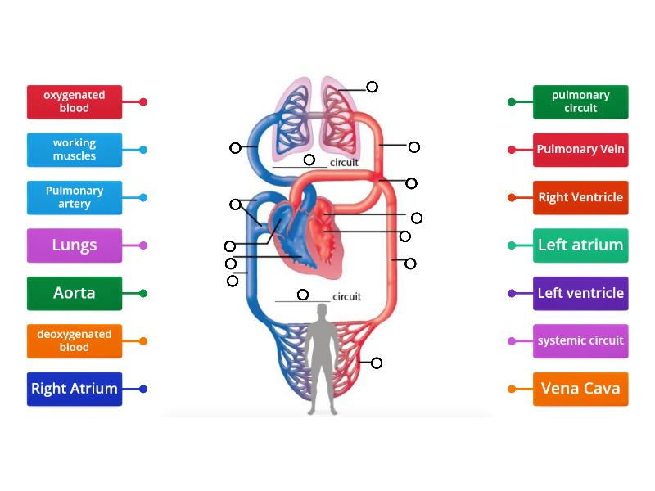

**Question 2 (3 Marks)**

**What is the role of the Cardiovascular System?**

­___________________________________________________________________________

­___________________________________________________________________________

­___________________________________________________________________________

­___________________________________________________________________________

­___________________________________________________________________________

­___________________________________________________________________________

­___________________________________________________________________________

­___________________________________________________________________________

­___________________________________________________________________________

**Question 3 Extended Response (16 Marks)**

**Explain the transport of gases through the respiratory and cardiovascular system.**

Label the diagram to assist your explanation (no marks allocated)

Use the diagram below to assist you in your answer

3. _____________

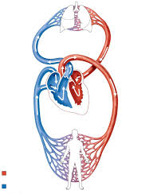

1. __________________

2. __________________

4. _____________

**Paragraph 1: _________________________________________ (4 Marks)**

*(What is happening at position 1. on the diagram?)*

­___________________________________________________________________________

­___________________________________________________________________________

­___________________________________________________________________________

­___________________________________________________________________________

­___________________________________________________________________________

­___________________________________________________________________________

­___________________________________________________________________________

­___________________________________________________________________________

­___________________________________________________________________________

­___________________________________________________________________________

­___________________________________________________________________________

­___________________________________________________________________________

­

**Paragraph 2: _________________________________________ (4 Marks)**

*(What is happening at position 2. on the diagram?)*

___________________________________________________________________________

­___________________________________________________________________________

­___________________________________________________________________________

­___________________________________________________________________________

­___________________________________________________________________________

­___________________________________________________________________________

­___________________________________________________________________________

­___________________________________________________________________________

­___________________________________________________________________________

­___________________________________________________________________________

­___________________________________________________________________________

­___________________________________________________________________________

­___________________________________________________________________________

­___________________________________________________________________________

­___________________________________________________________________________

­___________________________________________________________________________

**Paragraph 3: _________________________________________ (4 Marks)**

*(What is happening at position 3. on the diagram?)*

­___________________________________________________________________________

­___________________________________________________________________________

­___________________________________________________________________________

­___________________________________________________________________________

­___________________________________________________________________________

­___________________________________________________________________________

­___________________________________________________________________________

­___________________________________________________________________________

­___________________________________________________________________________

­___________________________________________________________________________

­___________________________________________________________________________

­___________________________________________________________________________

­___________________________________________________________________________

­___________________________________________________________________________

­___________________________________________________________________________

**Paragraph 4: _________________________________________ (4 Marks)**

*(What is happening at position 4. on the diagram?)*

­___________________________________________________________________________

­___________________________________________________________________________

­___________________________________________________________________________

­___________________________________________________________________________

­___________________________________________________________________________

­___________________________________________________________________________

­___________________________________________________________________________

­___________________________________________________________________________

­___________________________________________________________________________

­___________________________________________________________________________

­___________________________________________________________________________

­___________________________________________________________________________

­___________________________________________________________________________

­___________________________________________________________________________

­___________________________________________________________________________

­___________________________________________________________________________

Answers for Classroom Discussion

